

Please keep this portion as a receipt for your tax records.

-------------------------------------------------------------

Receipt for tax purposes:

Organization: Marshall Co. Reading Council

Member Name :

__________________________________

Date: ____________________________

Membership Value: $10

Building Rep. signature __________________________________

MARSHALL COUNTY READING COUNCIL

2017-2018

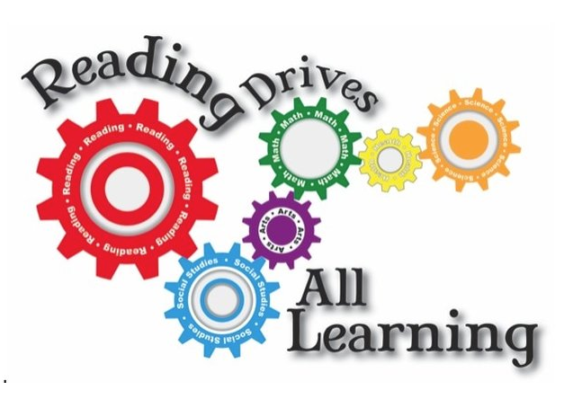

Join us for our upcoming state conference at Noblesville HS

September 16th, 9am-4pm.

**Featured Speakers Include:**

Matt Miller, author of **Ditch That Textbook!**

Visit indianareads.org for more information

Promoting reading & writing for Indiana children

Please detach this portion and return to your building rep., local library, or send to **Jenny Mevis**

By October 25th, 2017

Jenny Mevis

200 Triton Drive

Bourbon, IN 46504

jmevis@triton.k12.in.us

**1st Meeting**

Fall Brunch, October 7th

10:30 a.m. Barnes & Noble

Mishawaka, IN

**Program: Learn about new children's literature.**

** Coffee and Danishes provided!

2 gift cards will be raffled, and a fundraiser will be in action to support Books for Babies

**2nd Meeting**

Spring Banquet

March /April TBA

6pm @ Pretty Lake Church

Program: Professional development

**\*\* Full catered dinner with reservation**

**1 PGP certificate will be given to attendees.**

**3rd Meeting**

Young Author’s Conference

March / April TBA

Hosted by: **Plymouth Community Schools**

**Race for Reading**

November 11th, 2017

Plymouth Park / 5k / Silent Auction

**Membership Drive**

**Now through**

**October 25th, 2017**

Marshall County Reading Council was started in 1985 by a group of teachers of this county. It is a part of the national and state organizations of IRA (International Reading Association) and ISRA ( Indiana State Reading Association ).

The council’s purpose is to promote reading and writing in Marshall County. It does this through different programs and projects that it sponsors and supports throughout the year. Some of them are Celebrate Literacy, Books for Babies, **Classroom Grants, Scholarships,** PGP Certificates, and the Young Authors’ Conference.

The council invites *YOU* to be a part of the organization. Please check the inside for more information on how you can join what our program is this year.

*YOU* means

* Parents
* Teachers
* Librarians
* Education Students
* Community members
* Community members

To become a member, please fill out the form below and return it to your Reading Council Building Representative. You may also turn it in at your public library or mail it to:

Jenny Mevis

200 Triton Drive

Bourbon, IN 46504

**MCRC MEMBERSHIP**

**2017-18**

New Member _____ Renewal _____

Name __________________________

Address ________________________

City, Zip code ____________________

E-mail Address ___________________

School: ________________________

Are you currently a member of IRA? ____

IRA#/ Expiration Date ____________

Cost = $10.00 Please attach money or check made out to MCRC to this form.

_____ cash _____ check

**DUE BY: OCTOBER 25th**